## KAVAYATRI BAHINABAI CHAUDHARI NORTH MAHARASHTRA UNIVERSITY, JALGAON



**Project Report on**

“Study on Equity Research on Stock Market of India Infoline”

In partial fulfillment of Requirement for

# BACHELOR IN BUSINESS ADMINISTRATION

**Academic Year 2021-2022**

**Submitted By**

**Mr. RAMNEEY THAKURPRASAD PANDEY**

## Under the guidance of

**Prof. HARPREET SAINI**



## KCES’S INSTITUTE OF MANAGEMENT AND RESEARCH, JALGAON.

**ACKNOWLEDGEMENT**

It is my pleasure to place on record my sincere gratitude towards my guide Prof. Harpreet Saini, KCES’ s Institute of Management & Research, Jalgaon who spent his precious time providing continuous ideas and expert guidance to my project work. It was his direction and encouragement at every moment and step that motivated me to steer the research work confidently and successfully.

I am also thankful to our Director Dr. Shilpa Bendale mam and HOD Mamta Dahad whose encouragement, moral support and provide the valuable guidance, which has been a source of inspiration to me.

These all data collected on secondary base, which is derived by internet, books etc,…

Ramneey Thakurprasad Pandey

## DECLARATION

I hereby declare that this project entitled “Study on Equity Research in Stock Market.” is the result of my original research work and the same has not been previously submitted to any examination of this university or any other university. That project shall be liable to be rejected and / or cancelled if found otherwise.

Date: Ramneey Pandey

Place: Jalgaon

**INDEX**

|  |  |  |
| --- | --- | --- |
| SR. NO. | TOPIC | PAGE NO. |
| 1 | **Introduction** | 1 |
| 2 | **Theoretical Background** | 2 |
| 3 | **Company Profile** | 4 |
| 4 | **Product Profile** | 10 |
| 5 | **Objectives & Scopes** | 13 |
| 6 | **Research Methodology** | 16 |
| 7 | **Data Analysis & Interpretation** | 21 |
| 8 | **Limitations of Project** | 35 |
| 9 | **Conclusion & Suggestion** | 38 |
|  | **Bibliography** | 39 |
|  | **Annexure** | 40 |

# CHAPTER 1

## INTODUCTION

The main object of the project is to match the theoretical aspect. The project forms a vital element in the curriculum of UG.

It is the fact that the project gives the student first ever exposure to an organization thus the object enables the student to get familiar with the atmosphere in the organization.

During the course of study a management student gets depth of theoretical knowledge within the boundary of the institute. But after studying the books during the study, it is but natural that curiosity arises to know what exactly the management function in practical. But the problem is that these data are very vital and sensitive to any organization or firm.

Thus it cannot be seen that the project is that integral part of the management study which enables the student to develop his total personality as an efficient manager who can take up arising challenges of business work and lead his contents in the actual field of the management.

The stock market is one of the most important sources for companies to raise money. This allows businesses to go public, or raise additional capital for expansion.

The liquidity that an exchange provides affords investors the ability to quickly and easily sell securities. This is an attractive feature of investing in stocks, compared to other less liquid investments such as real estate.

Exchanges also act as the clearinghouse for each transaction, meaning that they collect and deliver the shares, and guarantee payment to the seller of a security. This eliminates the risk to an individual buyer or seller that the counterparty could default on the transaction.

The smooth functioning of all these activities facilitates economic growth in that lower costs and enterprise risks promote the production of goods and services as well as employment. In this way the financial system contributes to increased prosperity.

# CHAPTER 2

### THEORETICAL BACKGROUND

###### EQUITY RESEARCH

DEFINITION

A professional term for the work performed by [securities analysts,](http://www.investorwords.com/4438/securities_analyst.html) whose [profit](http://www.investorwords.com/8194/profit_forecast.html) [forecasts](http://www.investorwords.com/8194/profit_forecast.html) define "Street expectations" during an [earnings season](http://www.investorwords.com/8264/earnings_season.html). [Analysts](http://www.investorwords.com/209/analyst.html) are often assigned a [sector](http://www.investorwords.com/4430/sector.html) to [cover,](http://www.investorwords.com/1178/cover.html) such as biotech, [technology,](http://www.investorwords.com/17790/technology.html) [retail](http://www.investorwords.com/4228/retail.html) or [commodities.](http://www.investorwords.com/5873/Commodities.html) [Equity](http://www.investorwords.com/1726/equity.html) [research](http://www.investorwords.com/4201/research.html) is conducted through studying a [composite](http://www.investorwords.com/1005/composite.html) of [financial](http://www.investorwords.com/5572/financial.html) [records](http://www.investorwords.com/4094/record.html), news stories and interviews with [company](http://www.investorwords.com/992/company.html) [insiders.](http://www.investorwords.com/2488/insider.html) Also called [securities.](http://www.investorwords.com/5954/securities.html)

###### INTRODUCTION

The stock market is one of the most important sources for companies to raise money. This allows businesses to go public, or raise additional capital for expansion.

The liquidity that an exchange provides affords investors the ability to quickly and easily sell securities. This is an attractive feature of investing in stocks, compared to other less liquid investments such as real estate.

Exchanges also act as the clearinghouse for each transaction, meaning that they collect and deliver the shares, and guarantee payment to the seller of a security. This eliminates the risk to an individual buyer or seller that the counterparty could default on the transaction.

The smooth functioning of all these activities facilitates economic growth in that lower costs and enterprise risks promote the production of goods and services as well as employment. In this way the financial system contributes to increased prosperity.

For the operational procedure I visited the every Department of the Broking Firm & Collected the related Information.

For the fundamental Analysis I collected the Data from the Weekly Review of the IIFL. For the Various Fundamental & Technical Analysis I collected the Data from the various websites. The data analysis was done by using different statistical tools.

Observations were drawn from the data collected and compiled.

Fundamental Analysis is to the extent is good for the Long term calls but Not that much successful for the intraday calls .It is just the forecasting of the future, also it depends on the fundamentalist i.e. How he analyze the data? , How he predict the future base on that data? One should therefore use both the Fundamental as well as the Technical analysis.

No technical Analysis tool is also perfect, but it should be remembered that the indices are measuring what has already taken place; it is up to the interpreter to provide a meaningful forecast.

A chart does not provide with the means to predict future price action with certainty.

**CAPITAL MARKET** **MEANING AND CONCEPT**

Capital Market is one of the significant aspects of every financial market. Hence it is necessary to study its correct meaning. Broadly speaking the capital market is a market for financial assets which have a long or indefinite maturity. Unlike [money market instruments](http://kalyan-city.blogspot.com/2010/09/instruments-of-monetary-policy.html) the capital market instruments become mature for the period above one year. It is an institutional arrangement to borrow and lend money for a longer period of time. It consists of financial institutions like IDBI, ICICI, UTI, LIC, etc. These institutions play the role of lenders in the capital market. Business units and corporate are the borrowers in the capital market. Capital market involves various instruments which can be used for financial transactions. Capital market provides long term debt and equity finance for the government and the corporate sector. Capital market can be classified into primary and secondary markets. The primary market is a market for new shares, where as in the secondary market the existing securities are traded. Capital market institutions provide rupee loans, foreign exchange loans, consultancy services and underwriting.

Like the [money market](http://kalyan-city.blogspot.com/2010/09/money-market-concept-meaning.html) capital market is also very important. It plays a significant role in the national economy. A developed, dynamic and vibrant capital market can immensely contribute for speedy economic growth and development.

#### FINAL GLANCE

The lack of an advanced and vibrant capital market can lead to underutilization of financial resources. The developed capital market also provides access to the foreign capital for domestic industry. Thus capital market definitely plays a constructive role in the overall development of an economy.

# CHAPTER 3 COMPANY PROFILE

### INDIA INFOLINE LTD

India Infoline limited is listed on both the leading stock exchanges in India, i.e. The Bombay Stock Exchange (BSE) and the National Stock Exchange (NSE). It is engaged in the business of Equities broking, Wealth Advisory Services and Portfolio Management Services. It offers broking services in the Cash and Derivatives segments of the NSE as well as the Cash segment of the BSE. It is registered with the National Securities Depository Ltd. (NSDL) as well as Central Depository Services Ltd. (CDSL) as a depository participant, providing a one- stop solution for client trading in the equities market. A SEBI authorized Portfolio Manager; it offers Portfolio Management Services to clients.



|  |  |
| --- | --- |
| **SHAREHOLDERS**   * Growth at above industry rate with derisking * High ROCE, ROE | **GENERAL PUBLIC**   * Corporate Governance * Transparency |

### COMPANY VISION

The companies Vision is to be **“The most respected company in the financial services space.”**

###### The box below elaborates how the company proposes to attain the vision of being the

**most respected company in the space.**

|  |  |
| --- | --- |
| **CUSTOMERS**   * Cutting edge technology * High service standards | **EMPLOYEES**   * Skill development by investments in training * Empowerment and conducive   work environment |

### SLOGAN

***“IT’ S ALL ABOUT MONEY, HONEY!”***

### HEAD OFFICE

India Info line Ltd., 75, Nirlon Complex,

Off, Western Express Highway, Goregaon (East), Mumbai 400063.

### WEB ADDRESS:

[www.indiainfoline.com](http://www.indiainfoline.com/) [www.5paise.com](http://www.5paise.com/)

**Members of the Management**

|  |  |
| --- | --- |
| **Mr. Nirmal Jain sir** | **Chairman and Managing Director** |
| **Mr.R Venkatraman** | **Managing Director** |
| **Mr.Kranti Sinha** | **Independent Director** |
| **Mr.Arun K. Purvar** | **Independent Director** |
| **Mr.Nilesh Vikamsey** | **Independent Director** |

**CHAPTER 4**

**PRODUCT PROFILE**

**PRODUCT AND SERVICE**

We are a one-stop financial services shop, most respected for quality of its advice, personalized service and cutting-edge technology.

###### Equities Broking:

India Infoline provided the prospect of researched investing to its clients, which was hitherto restricted only to the institutions. Research for the retail investor did not exist prior to India Infoline. India Infoline leveraged technology to bring the convenience of trading to the investor’s location of preference (residence or office) through computerized access. India Infoline made it possible for clients to view transaction costs and ledger updates in real time

###### Portfolio Management Services:

Our Portfolio Management Service is a product wherein an equity investment portfolio is created to suit the investment objectives of a client. We at Indiainfoline invest your resources into stocks from different sectors, depending on your risk-return profile. This service is particularly advisable for investors who cannot afford to give time or don't have that expertise for day-to-day management of their equity portfolio.

###### Research & Content:

Sound investment decisions depend upon reliable fundamental data and stock selection techniques. India Infoline Equity Research is proud of its reputation for, and we want you to find the facts that you need. Equity investment professionals routinely use our research and models as integral tools in their work. They choose Ford Equity Research when they can clear your doubts.

###### Commodities:

India Infoline’s extension into commodities trading reconciles its strategic intent to emerge as a one-stop solutions financial intermediary. Its experience in securities

broking has empowered it with requisite skills and technologies. The Company’ s commodities business provides a contra-cyclical alternative to equities broking. The Company was among the first to offer the facility of commodities trading in India’ s young commodities market (the MCX commenced operations only in 2003). Average monthly turnover on the commodity exchanges increased from Rs 0.34 bn to Rs 20.02 bn. The commodities market has several products with different and non-correlated cycles. On the whole, the business is fairly insulated against cyclical gyrations business.

###### Life Insurance:

An entry into this segment helped complete the client’ s product basket; concurrently, it graduated the Company into a one-stop retail financial solutions provider. To ensure maximum reach to customers across India, we have employed a multi pronged approach and reach out to customers via our Network, Direct and Affiliate channels. Following the opening of the sector in 1999-2000, a number of private sector insurance service providers commenced operations aggressively and helped grow the market.

The Company’s entry into the insurance sector derisked the Company from a predominant dependence on broking and equity-linked revenues. The annuity based income generated from insurance intermediation result in solid core revenues across the tenure of the policy.

###### Invest In Mutual Fund:

India Info line offers you a host of mutual fund choices under one roof, backed by in- depth research and advice from research house and tools configured as investor friendly.

###### Wealth Management Services:

Imagine a financial firm with the heart and soul of a two-person organization. A world leading wealth management company that sits down with you to understand your needs and goals. We offer you a dedicated group for giving you the most personal attention at every level.

###### Mortgages:

During the year under review, Indiainfoline acquired a 75% stake in Money tree Consultancy Services to mark its foray into the business of mortgages and other loan products distribution. The business is still in the investing phase and at the time of the acquisition was present only in the cities of Mumbai and Pune. The Company brings on board expertise in the loans business coupled with existing relationships across a number of principals in the mortgage and personal loans businesses. Indiainfoline now has plans to roll the business out across its pan-Indian network to provide it with a truly national scale in operations

# CHAPTER 5

**Objectives & Scope**

### OBJECTIVE

It was good opportunity to familiarize myself with the stock market i.e. the capital market & their co-relation with economical environment through **“ EQUITY RESEARCH**” . The analysis of equity gives me the opportunity to understand thoroughly these behavioral patterns of different equity & overall capital market.

Objectives of the Study are as follows.

1. To study the operational procedure of a broking Firm.
2. To Learn the Fundamental analysis Tools for determining the Intrinsic Value of the share.
3. To learn the various charts of the technical Analysis such as Bar charts, candlestick charts etc.
4. To Study the equity analysis and obtain the knowledge of equity market

5 To Study the present behavior & predicting the future behavior of equity in Stock market.

6. Obtain the knowledge about how to select the companies for investment.

### SCOPE

Scope of the stock Market is very Large, know can know the stock market in months or year. Even a 20-25 years experienced person cannot understand the stock market in full extent. Here I just tried to clear concepts of the stock market to a very small extent.

Scope of the study is to understand the operational procedure of a Broking firm, to analyze the various terms in stock market. To analyze the Techniques of the fundamental analysis & technical analysis in details. To analyze the various techniques of the stock price forecasting.

# CHAPTER 6 RESEARCH METHODOLOGY

### RESEARCH METHODLOGY

Research methodology is a way to systematically solve the research problem. It can be understood as a science of studying how research is done scientifically. It takes many dimensions and research methods to constitute a part of the research methodology. Thus when we talk of research methodology, we not only talk of the research methods but also consider the logic behind the methods used in context of the research study in such a way that results are capable of being evaluated either by the researcher himself or by others. Under this head, the methods and techniques used in preparing this report are discussed

###### MEANING OF RESEARCH

“A careful critical inquiry or examination in seeking facts or principles; diligent investigation in order to ascertain something” .

Dictionary)

(Webster’s International

“Any organized inquiry designed & carried out to provide Information for

solving a problem” .

(William C. Emory)

Every work needs some time & proper sequence or order to complete it. It gives you better results

“Research Methodology” is a systematic investigation of pertinent information. It is also called an Enquiry of unknown facts for the sake of knowledge”

In the RM there are 2 types of data-----------

1. Primary data
2. Secondary data

### Primary data

Personal interview is the main tool for the collection of primary data and information. But I personally took secondary data.

### Secondary data

Since the study is based on the financial aspects of the company so the annual report of the company brought in use. Beside the above data, the company profile and the theoretical aspects are taken from the secondary sources.

### Primary source includes:-

1. Discussion with branch manager
2. Discussion with experts
3. Questionnaires for investors
4. Live trading in the market

### Secondary source includes:-

* 1. Various books related to stock market
  2. Books related to Financial Management
  3. Web sites were used as the vital information source.

|  |  |
| --- | --- |
| **Primary data** | **Secondary data** |
| It is a fresh & original | It is not original but rather obtained from  published or unpublished sources |
| It did not used by anyone | It already used by someone else for any  purpose |
| E.g. interviews, questionnaire, survey etc… | E.g. published reports, individual reports, statistical reports, financial statements,  commercial data etc. |

# CHAPTER 7

## DATA ANALYSIS & INTERPRITATION

### EQUITY ANALYSIS

###### FUNDAMENTAL ANALYSIS

The investor, while buying stock, has the primary purpose of gain. If he invests for a short period of time, it is speculative but when he holds if for a fairly long period of time, the anticipation is that he would receive some return on his investment. The fundamental analysis is a method of finding out the future price of a stock, which an investor wishes to buy. The method for forecasting the future behavior of investment and the rate of return on them is clearly through an analysis of the broad economic forces, industry analysis, the company analysis and ration analysis.

### Influence of the economy on the company

###### These are the following factor: -

* 1. Economic Growth
  2. Populations
  3. Monsoons and Agriculture Production
  4. Natural resources and availability of raw material
  5. Industrial Productions
  6. Inflation
  7. Interest rate
  8. Foreign exchange reserve
  9. Balance of payment position
     1. Budget deficits
     2. Public debt and foreign debt
     3. Domestic saving and capital output rate
     4. Employments
     5. Taxation policies
     6. Infrastructure facilities
     7. Government policies
     8. Political Stability
     9. International developments
     10. Capital formations
     11. Saving pattern
     12. Economic indicators
     13. Foreign direct investments
     14. Rupee-Dollar Fluctuation
     15. Stock News

### Industrial Analysis

The industry analysis should take in to account the following factors as influence the performance of the company, whose share prices are to be analyzed.

###### Product Line.

It is also necessary to know the industries with a high growth potential like computers, electronics, chemicals, diamonds, textiles etc. and whether the industry is in the priority sector of the key industry group of capital goods or consumer’ s goods group.

###### Raw Material and Inputs.

Under these head, we have to look in to industries depending on imports of scare raw materials, competition from other companies and industries and the barriers to entry of new company, protection from foreign competition, import and export restriction etc.

###### Capacity Installed and Utilized.

The demand for industrial product in the economy is estimated by the planning commission and the Government, and the units are given licensed capacity on the basis of these estimates.

###### Industry Characteristics.

It included whether the industry is cyclical, fluctuating of stable. It is also important industry produce seasonal product or FMCG. It also included demand of product freight charges, cost of production, advertisement cost, skill of operation, profitability.

###### Demand and Market.

It includes demand of the product in the market and price of raw material and other input cost like freight, electricity, season, monsoon, etc. if the nature of product is such as drugs, fertilizer or other consumer goods, whose price and distribution control by Government.

###### Government Policy with regard to Industry

Government Policy is announced in the industrial policy resolution and

Subsequent announcement from time to time by the Government. The Policy strategy as laid down in the five years plans according to planning commission and expected demand in the economy.

###### Management

If the promoters and the management are the efficient and capable of steering the company through the difficult days such management likes TATA & BIRLA, who have reputation, buildup their companies on the strong foundation. The management has to be assessed in the terms of their capabilities, popularity, honesty and integrity.

### TECHNICAL ANALYSIS

The methods used to analyze securities and make investment decisions fall into two very broad categories: **Fundamental Analysis and Technical Analysis.** Fundamental analysis involves analyzing the characteristics of a company in order to estimate its value. Technical analysis takes a completely different approach; it doesn’ t care one bit about the “ **value**” of a company or a commodity. Technicians (some time called chartists) are only interested in the price movement in the market.

Despite all the fancy and exotic tools it employs, technical analysis really just studies **supply and demand** in a market in an attempt to determine what direction, or **trend**, will continue in the future. In other words, technical analysis attempts to understand the emotions in the market by studying the market itself, as opposed to its components. If you understand the benefits and limitation of technical analysis it can give you a new set of tools or skills than will enable you to better trader or investor.

# CHAPTER 7

## DATA INTERPRITATION

### DEFINITION

Technical analysis is a method of evaluating the securities by analyzing the statistics generated by the market activity, such as past price and **volume.** In technical analysis, analysts use charts and other tools to identify **patterns** that can suggest future activity.

Just as there are many investment styles on fundamental side, there is also much different type of technical traders. Some rely on chart patterns. In any case, technical analyst’ s exclusive use of historical price and volume data is what separates them from their fundamental counterparts. Unlike fundamental analysis technical analysts don’ t care whether a stock is **undervalued** the only thing that matter is a security’ s past trading data and what information this data can provide about where the security might move in the future

### Line charts

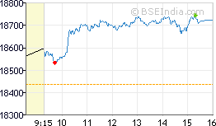A style of charts that is created by connecting a series of data points together with a line. This is the most basic type of charts used in finance and connecting a series of past prices together with a line generally creates it.

### Bar chart

A style of chart used by some technical analysts, on whom as illustrated below, the top of the vertical line indicates the highest price a security traded at during the day, and the bottom represents the lowest price. The closing price is displayed on the right side of the bar, and the opening price is shown on the left side of the bar. A single bar like the one below represents one day of trading.

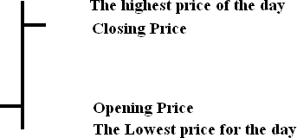

These are the most popular type of chart used in technical analysis. The visual representation of price activity over a given period of time is used to spot trends and patterns.

### Candlestick

A price chart that displays the high, low, open and close for a security each day over a specified period of time.

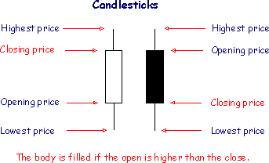

There are many trading strategies based upon patterns in candlestick charting

### Technical analysis: the use of trend

One of the most important concepts in technical analysis is that of trend. The meaning in finance isn’ t all that different from the general definition of the term- a trend is really nothing more than the general direction in which a security or market is headed. Take a look at the chart below:

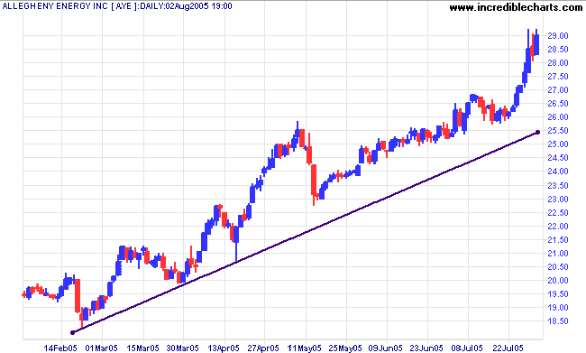

It isn’ t hard to see that the trend in figure is up. However, isn’ t not always this easy to see a trend.

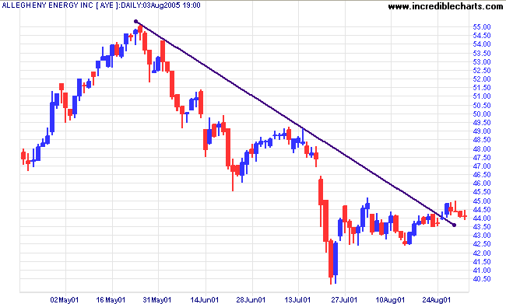

### The Importance of Trend

It is important to be able to understand and identify trends so that you can trade with them rather than trade against them. Two important sayings in technical analysis are “ the trend is your friend” and “ don’ t buck the trend” Illustrating how important trend analysis is for technical trade.

### Types of Trend

###### There are three types of trend:

* Up Trends
* Downtrends
* Sideways/ Horizontal Trends

### Uptrend

Describes the price movement of a financial asset when the overall direction is upward. A formal uptrend is when each successive peak and trough is higher than the ones found earlier in the trend.

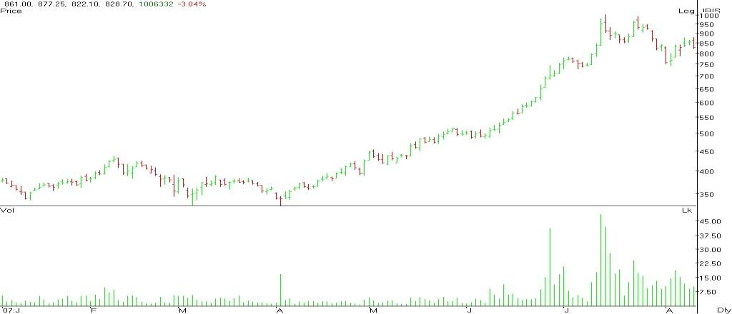

Notice how each successive peak and trough is located above the previous ones. For example, the peak at trend is higher than the peak at uptrend. The uptrend will be deemed broken if the next low on the chart falls below trend.

### Downtrend

Describes the price movement of a financial asset when the overall direction is downtrend. A formal downtrend occurs when each successive peak and trough is lower than the ones found earlier in the trend.

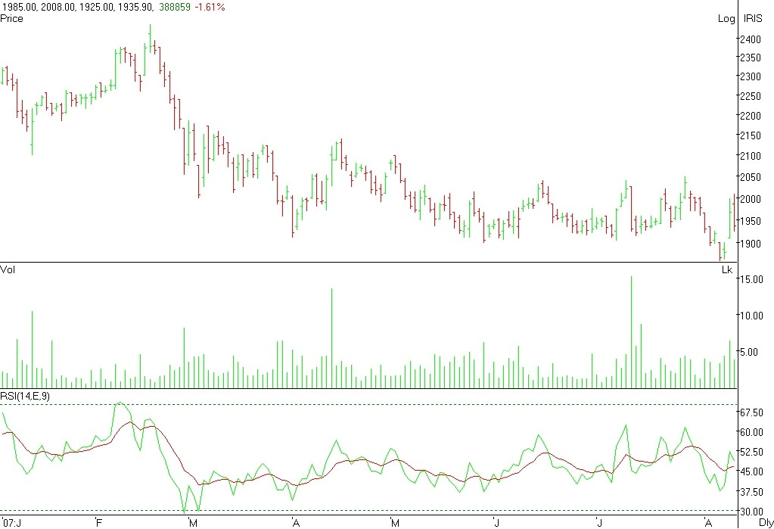

Notice how each successive peak and trough is lower than the previous one. For example, the low trend is lower than the low at Point. The downtrend will be deemed broken once the price closes above the high at high direction trend.

Downtrend is the opposite of uptrend.

### Trend lines

A trend line is a simple charting technique that adds a line to a chart to represent the trend in the market or a stock. Drawing a trend line is as simple as drawing a straight line that follows a general trend. These lines are used to clearly show the trend and are also used in the identification of the reversals.



According to chart, an upward trend lines is drawn at the lows of an upward trend. This line represents the support the stock has every time it moves from a high to a low. Notice how the price is propped up by this support. This type of trend line helps traders to anticipate the point at which a stock’ s price will begin moving upwards again. Similarly, a downward trend line is drawn at the highs of the downward trend. This line represents the resistance level that a stock faces every time the price moves from a low to a high.

### Trend Lengths:

Along with this trend direction, there is three-trend classification. A trend of any direction can be classified as a long-term trend, intermediate trend or a short-term. In terms of the stock market, a major trend is generally categorized as one lasting longer than a year. An intermediate trend is considered to last between one and three months and a near-term trend is anything less than a month. A long-term trend is composed of several intermediate trends, which obtain move against the direction of the major trend. If the major trend is upward and there is a downward correction in price movement followed by a continuation of the uptrend, the correction is considered to be an intermediate trend. The short term trends are components both major and intermediate trends. Take a look a Figure to get a sense of how these three trends lengths might look.

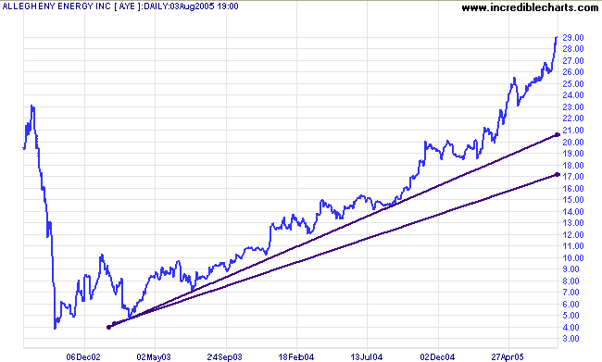

### Channels

A Channel, or channel lines, is the addition of two parallel trend lines that act as strong areas of support and resistance. The upper trend line connects a series of highs, while the lower trend line connects a series of lows. A channel can slope upward, downward or sideways but regardless of the direction, the interpretation remains the same. Traders will expect a given security to trade between two levels of support and resistance until it breaks beyond one of the levels in which case traders can expect a sharp move in Direction of the break. Along with clearly displaying the trend, channel is mainly used to illustrate important areas of support and resistance.

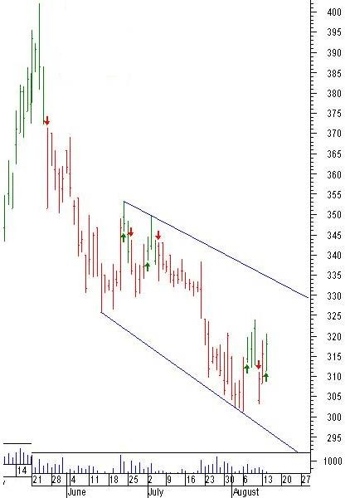

Above graph a descending channel on stock chart; the upper trend line has been placed on the highs and lower trend line is on the lows. The price has bounced off of these line several times, and has remained range-bound for several months. As long as the price does not fall below the lower line or move beyond the upper resistance, the range bound downtrend is expected to continue.

### Double Bottom

A charting pattern used in technical analysis. It describes the drop of a stock (or index), a rebound, another drop to the same (or similar) level as the original drop, and finally another rebound.

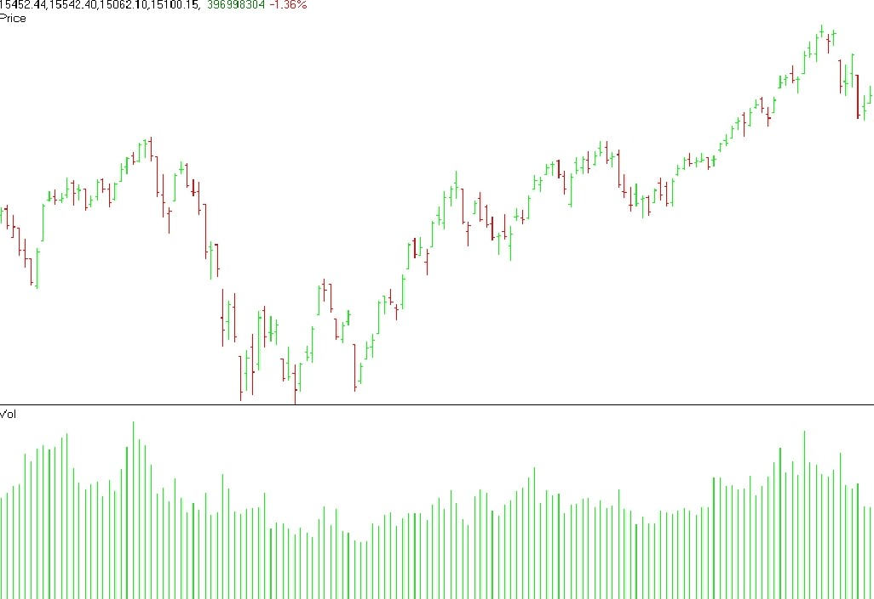

### Double Top

A term used in technical analysis to describe the rise of a stock, a drop, another rise to the same level as the original rise, and finally another drop.

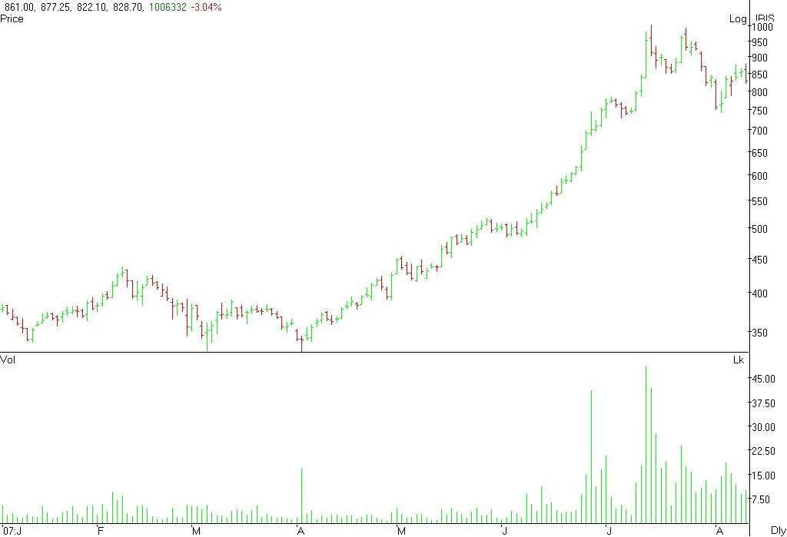

The double top looks like the letter “ M” .The twice-touched high is considered resistance level.

### Triple Bottom

A pattern used in technical analysis to predict the reversal of a prolonged downtrend. The pattern is identified when the price of an asset creates three troughs at nearly the same price level. The third bounce off the support is an indication that buying interest (demand) is outweighing selling interest (Supply) and that trend is in the process of reversing.

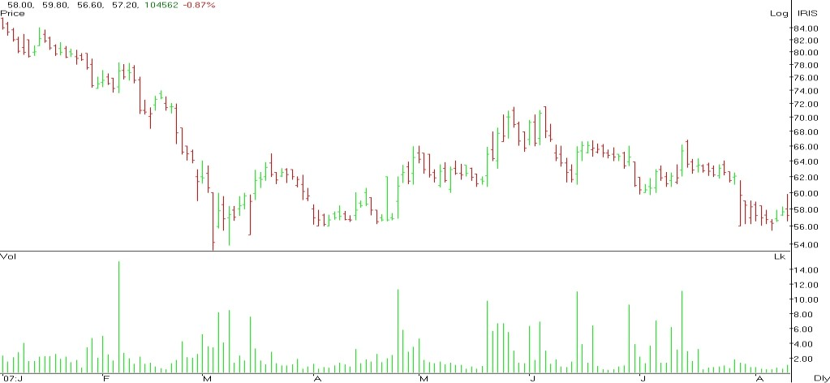

**1**

**2**

**3**

Once the first bottom is created, the price reaches a peak and retraces back toward the prior support. This is when buyer enters again and pushes the price of the asset higher, creating bottom No.2. The price of the asset then created another peak and heads lower for its final test of the support. The final bounce of the support level creates bottom No.3 and traders will get ready to enter a long position once the price breaks above the previous resistance (Illustrated by the black on the chart). This pattern is considered to be a very reliable indication that the downtrend has reversed and that the new trend in the upward direction. Sudden change in the price direction of a stock, index, commodity or derivative security. Also referred to as a “ Trend Reversal” , “ Rally” or “ Correction**” .**

### Triple Top

A pattern used in technical analysis to predict the reversal of prolonged up trend. This pattern is identified when the price of an asset creates three peaks at nearly the same price level. The bonus off the resistance near the third peak is clear indication that buying interest is becoming exhausted. The traders to predict the reversal of the up trend use it.

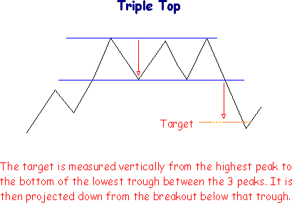

The three consecutive tops make this pattern visually similar to the head and shoulders pattern but, in this case, the middle peak is nearly equal to the other peak rather than being higher. Many traders will enter into a short position once the price of asset falls below the identified support level. (Shown by the line in the chart above).

### Head and Shoulders Pattern

A technical analysis term used to describe a chart formation in which a stock’ s price:

1 Rises to a peak and subsequently declines.

1. Then, the price rises above the former peak and again declines
2. And finally, rises again, but not to the second peak, and declines once more.

The First and Third peaks are shoulders, and second peak forms the head.

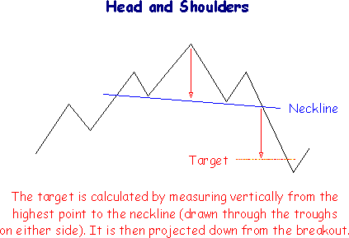

The “ Head -and – Shoulders” pattern is believed to be one of the most reliable trend reversal patterns.

### Volume

The number of shares or contracts traded in a security or an entire market during a given period of time. It is simply the amount of shares that trade hands from sellers to buyers as a measure of activity. If a buyer of a stock purchases 100 shares from a seller, then the volume for that period increases by the 100 shares based on that transaction.

Volume is an important indicator in the technical analysis as it is used to measure the worth of a market move. If the market have made strong price move either up or down the perceived strength of that move depends on the volume of that period. The higher the volume during that price move the more significant the move.

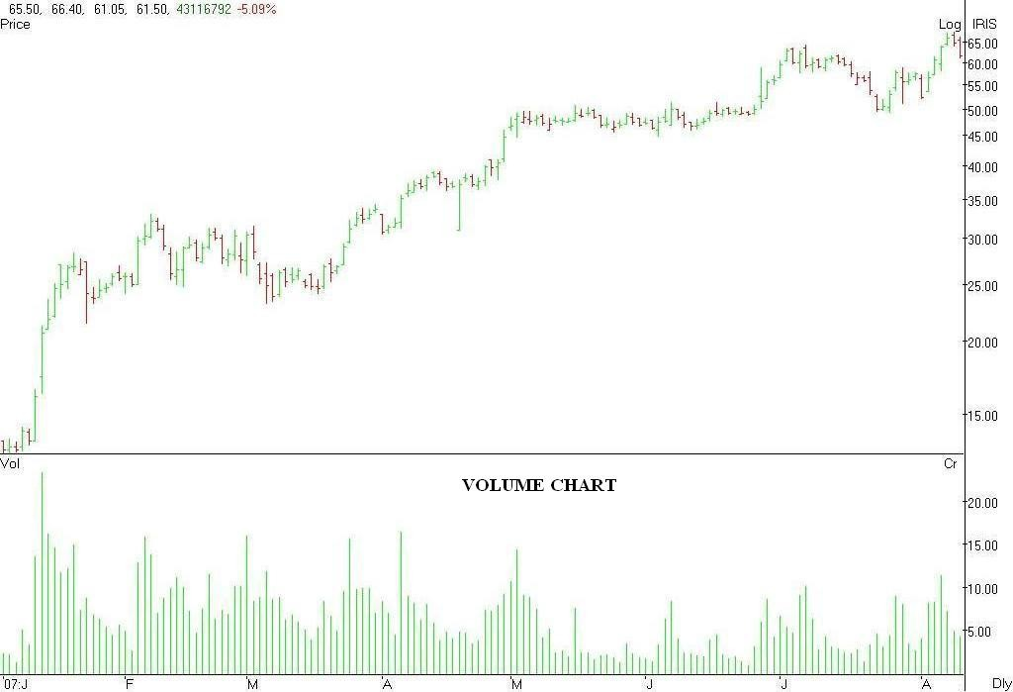

### Support

The price, which, historically, a stock had difficulty falling below. It is thought of as the level at which a lot of buyers tend to enter the stock. Often referred to as the “ Support Level” .

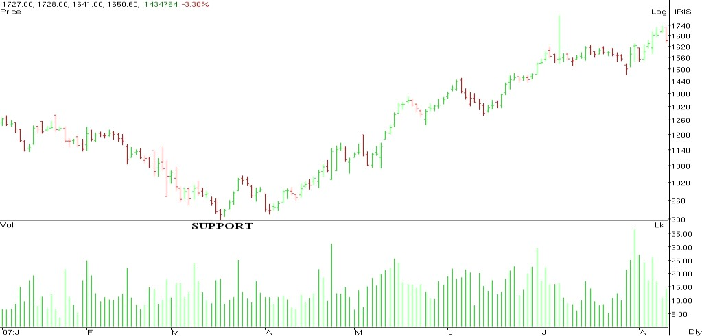

### Resistance

The Price at which a stock or market can trade, but which it cannot exceed, for a certain period of time. Often referred to as “ Resistance Level” .

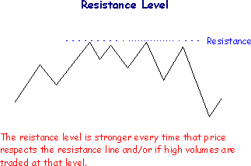

### Moving Average- MA

An indicator frequently used in technical analysis showing the average value of a security’ s price over a set of period. Moving averages are generally used to measure momentum and define areas of possible support and resistance.

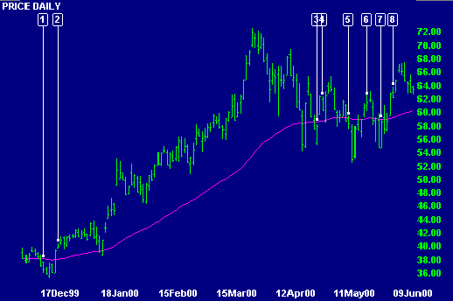

# 

# CHAPTER 8

## LIMITATIONS OF THE PROJECT

### LIMITATIONS OF STUDY

* To understand the overall working of share market, the period of 60 days is not enough.
* Moreover, very few investor and agents have a detail knowledge of the study.
* A study is conducted in Nasik only, which restrict the scope of the study
* The data provided by the investor and the agents can’ t be held true as 100% correct.
* The study was conducted to understand with respect to fundamental and technical analysis, which is a part of the equity share market.

# CHAPTER 9

## CONCLUSION & SUGGESTION

### CONCLUSION

With the help of project I concluded that blue chip companies are playing very important role in the share market. Lot of investors is investing their money in the blue chip companies. And this is the reason that the volume of blue chip companies is high.

During this period of two months I came to know that in the process of equity analysis of blue chip companies two weapons are playing a vital role i.e. Fundamental Analysis and Technical Analysis.

The concept of Fundamental Analysis studies the performance of blue chip companies. With the help of Fundamental Analysis can know the past performance of the blue chip companies. Fundamental Analysis considers the long-term performance of companies and this helps the investors to invest their money for long term as well as can get the good returns.

Technical Analysis comprises short-term analysis of blue chip companies. Technical Analysis really just studies supply and demand in the market in an attempt to determine what direction or trend will continue in the future.

The study of technical as well as fundamental analysis can give detail information about the well running companies in the market. Before investing in any company one should study these two concepts.

### SUGGESTION

Following are suggestions made based on study with reference to watch on NEAT Screen, interaction with clients, data analysis and findings:

1. In IT sector Infosys is very good because it’ s EPS is continuously increasing and company have given 300 % dividend it means stock is strong by fundamentally and technically it is also growing very well people should invest in this stock
2. Reliance Industries is also looking strong by fundamentally and technically, in future it is entering in to new business, merger with other company so this is also good option for investment.
3. Technically L&T is in rising pattern, company offered the bonus share 1:1 per share and gross profit and net profit is consistent. This is good stock for investment
4. It is always better to invest money on long term basis than intraday because intraday is nothing but a speculation
5. If people consider both i.e. fundamental analysis and technical analysis then it will be better than speculation
6. Currently IT sector is in boom so it is better to invest money in IT and also good in Banking sector

### Suggestion Chart

|  |  |  |  |  |  |  |  |
| --- | --- | --- | --- | --- | --- | --- | --- |
| **Script** | **EPS** | **Dividends** | **Bonus** | **Result** | **CMP** | **Target Price** | **Stop- Loss**  **Price** |
| **Infosys** | 19.96 | 300% | -- | Sale | 1976 | 2040 | 2020 |
| **Reliance** | 20.5 | 100% | -- | ? HOLD | 1894 | 1945 | 1795 |
| **L & T** | 24.95 | 500% | 1:1 | Sale | 2608 | 2750 | 2640 |

## BIBLIOGRAPHY

* **Book Reference**

**Financial Management by Ravi Kishore**

**Financial Management by S M Gupta**

**Financial Management by E F Brigham**

* **Websites**

[**www.indianinfoline.com**](http://www.indianinfoline.com)

[**https://in.linkedin.com**](https://in.linkedin.com)

[**www.5paise.com**](http://www.5paise.com)

[**www.economictimes.com**](http://www.economictimes.com)